Week 8 extra programs

/*1. Write a program which has an abstract class Solid and implements cylinder, cone and

sphere by inheriting from solid to find surface area and volume.*/

import java.util.*;

abstract class solid

{

int a,b;

abstract void surface_area();

abstract void volume();

}

class cylinder extends solid

{

float area,vol;

void surface_area()

{

area=(2.0f*3.14f*a*b)+(2.0f*3.14f*a*a);

System.out.println("surface area of cylinder = "+area);

}

void volume()

{

vol=3.14f*a*a*b;

System.out.println("volume of cylinder = "+vol);

}

}

class cone extends solid

{

float area,vol;

void surface_area()

{

float l=(float)Math.sqrt(a*a+b*b);

area=(3.14f*a*l)+(3.14f*a*a);

System.out.println("surface area of cone = "+area);

}

void volume()

{

vol=3.14f*a*a*b/3.0f;

System.out.println("volume of cone = "+vol);

}

}

class sphere extends solid

{

float area,vol;

void surface_area()

{

area=4.0f*3.14f*a*a;

System.out.println("surface area of sphere = "+area);

}

void volume()

{

vol=4.0f*3.14f*a*a*a/3.0f;

System.out.println("volume of sphere = "+vol);

}

}

class solids

{

public static void main(String args[])

{

Scanner sc=new Scanner(System.in);

cylinder a1=new cylinder();

System.out.println("enter radius and height of cylinder");

a1.a=sc.nextInt();

a1.b=sc.nextInt();

cone a2=new cone();

System.out.println("enter radius and height of cone");

a2.a=sc.nextInt();

a2.b=sc.nextInt();

sphere a3=new sphere();

System.out.println("enter radius of sphere");

a3.a=sc.nextInt();

a1.surface_area();

a1.volume();

a2.surface_area();

a2.volume();

a3.surface_area();

a3.volume();

}

}

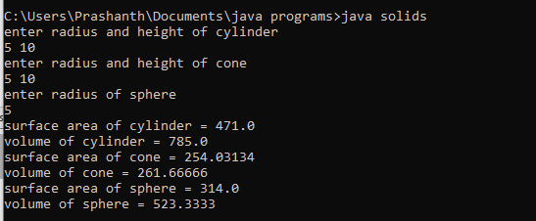

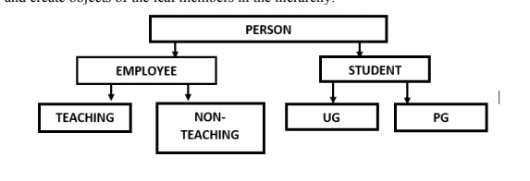

/*2. Develop a Java program to implement the hierarchy given below. Include atleast one

appropriate member in each of these classes. Set and display details in each of the class

and create objects of the leaf members in the hierarchy.*/

/*2. Develop a Java program to implement the hierarchy given below. Include atleast one

appropriate member in each of these classes. Set and display details in each of the class

and create objects of the leaf members in the hierarchy.*/

class person

{

String name="neha";

void disp_person()

{

System.out.println("name of the person : "+name);

}

}

class employee extends person

{

int age=35;

void disp_age_emp()

{

super.disp_person();

System.out.println("age of employee : "+age);

}

}

class student extends person

{

int age=22;

void disp_age_stud()

{

super.disp_person();

System.out.println("age of student : "+age);

}

}

class teaching extends employee

{

String qual="M.Tech";

void disp_teaching()

{

super.disp_age_emp();

System.out.println("qualification of teaching staff: "+qual);

}

}

class non_teaching extends employee

{

String qual="MBA";

void disp_non_teaching()

{

super.disp_age_emp();

System.out.println("qualification of non teaching staff: "+qual);

}

}

class ug extends student

{

String dep="computer science";

void disp_ug()

{

super.disp_age_stud();

System.out.println("department of ug student : "+dep);

}

}

class pg extends student

{

String dep="MSc in artificial intelligence";

void disp_pg()

{

super.disp_age_stud();

System.out.println("department of pg student : "+dep);

}

}

class general

{

public static void main(String args[])

{

teaching o1=new teaching();

non_teaching o2=new non_teaching();

ug o3=new ug();

pg o4=new pg();

System.out.println("-------------------------------------------");

o1.disp_teaching();

System.out.println("-------------------------------------------");

o2.disp_non_teaching();

System.out.println("-------------------------------------------");

o3.disp_ug();

System.out.println("-------------------------------------------");

o4.disp_pg();

}

}

